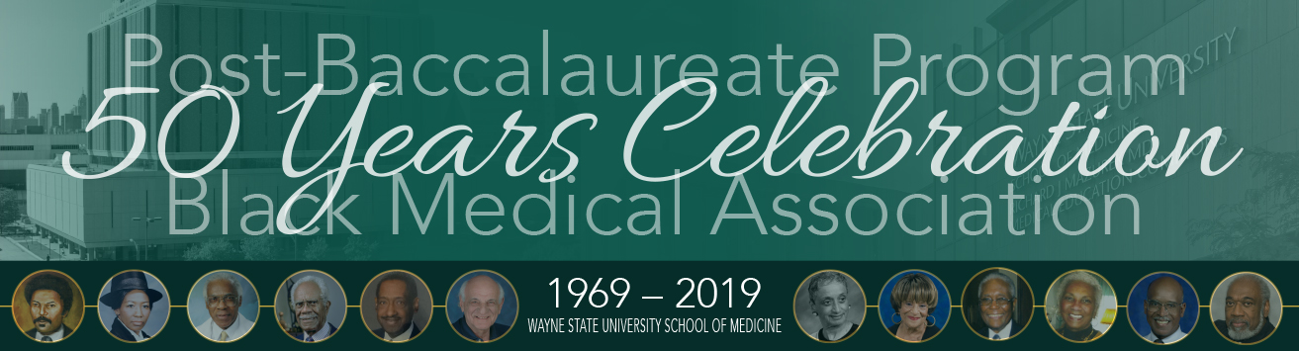

**Individual Ticket Order Form**

Thank you for attending the Post Baccalaureate Program and the Black Medical Association  
50 Years Celebration on May 19, 2019. Please submit this form with payment no later than May 16.

**Tickets:  
Prayer Breakfast and 50th Anniversary Post Bac Celebration***May 19, 9AM- Noon, Detroit Yacht Club*

_____ @ $100 (per person)

_____ @ $50 (sponsor a student)

­­­_____ @ $50 (WSUSOM faculty, staff or administrator)

**Prayer Breakfast, 50th Anniversary Post Bac Celebration and Cookout***May 19, 9AM- 5PM, Detroit Yacht Club*

_____ @ $130 (per person)

_____ @ $80 (sponsor a student)

_____ @ $80 (WSUSOM faculty, staff or administrator)

______ I would like to make a donation of $_________________ (payable to WSU School of Medicine)

Name:

Contact Name:

Address:

City/State/ZIP:

Phone:

Email Address

**□ Check enclosed:** M*ake check payable to* **Keep it Real Ministry**

*M****ail this form with check payable to Keep it Real Ministry*** *to: Wayne State University School of Medicine Office of Development and Alumni Affairs, 540 E. Canfield, 1369 Scott Hall, Detroit, MI 48201. For questions and additional information, call Anita Moncrease, M.D., at 248-552-8825.*