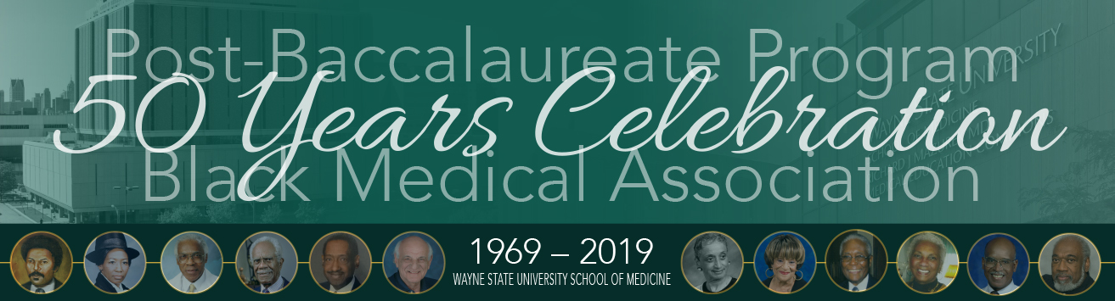

**PROGRAM ADVERTISEMENT FORM**

Thank you for supporting the Post Baccalaureate Program and the Black Medical Association  
***50 Years Celebration*** by purchasing an advertisement for the souvenir program book. Please submit this form, ad and payment by May 9**.**

**Advertisement size:**

□ $1,500 Back outside cover; Full Page (4.75” w X 8” h)

□ $1,000 Back inside cover; Full Page (4.75” w X 8” h)

□ $500 Full page (4.75” w X 8” h)

□ $275 Half page (4.75” w X 3.75” h)

□ $150 Quarter page (2.25” w X 3.75” h)

□ $50 Patron

Name of Advertiser:

Contact Name:

Address:

City/State/ZIP:

Phone:

Email Address

**□ Check enclosed:** M*ake check payable to* **Keep it Real Ministry**

*Advertisements are full color. All advertising and photographs must be camera-ready and sized to the above dimensions. Acceptable format is a high-quality print PDF.* ***Submit your completed advertisement*** *by email to* [curtishbk@hmbcdetroit.org](mailto:curtishbk@hmbcdetroit.org). ***Ad Deadline: May 9, 2019.***

*M****ail this form with check payable to Keep it Real Ministry*** *to: Wayne State University School of Medicine Office of Development and Alumni Affairs, 540 E. Canfield, 1369 Scott Hall, Detroit, MI 48201. For questions or additional information, call Anita Moncrease, M.D., at 248-552-8825.*