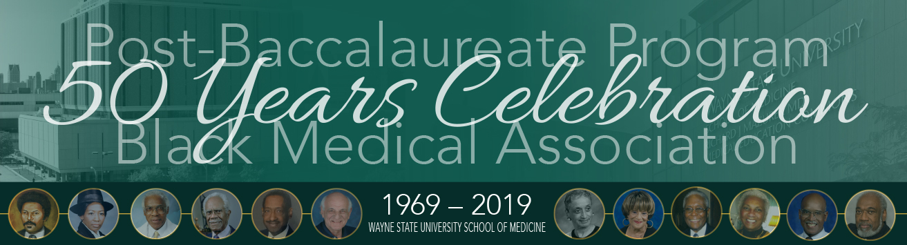

**SPONSORSHIP FORM**

Thank you for your sponsorship of the Post Baccalaureate Program and the Black Medical Association ***50 Years Celebration*** on May 19, 2019. Please submit this form with payment by May 16**.** Ad deadline is May 9.

Name of Organization: ______________________________________________________

Name of Contact Person (*Please Print*): _________________________________________

Contact Phone Number: _________________ E-mail: __________________________

I would like to be a:

[ ] **Platinum Sponsor: $ 2,500**

Benefits include: 10 tickets to the breakfast, program and cookout

Full-page color advertisement in the Souvenir Book

Table and banner at the breakfast and cookout to promote your organization

[ ] **Gold Sponsor**:   **$ 2,000**

Benefits include: five tickets to the breakfast, program and cookout

½ -page color advertisement in the Souvenir Book

Table and banner at the breakfast and cookout to promote your organization

[ ] **Silver Sponsor:**    **$ 1,000**

Benefits include: two tickets to the breakfast, program and cookout

1/4-page color advertisement in the Souvenir Book

Table and banner at the breakfast and cookout to promote your organization

[ ] I would like to make a donation of $_________________ (payable to WSU School of Medicine)

*Advertisements are full color. All advertising and photographs must be camera-ready and sized to the above dimensions. Acceptable format is a high-quality print PDF.* ***Submit your completed advertisement*** *by email to* [curtishbk@hmbcdetroit.org](mailto:curtishbk@hmbcdetroit.org). ***Ad Deadline: May 9, 2019.***

*M****ail this form with check payable to Keep it Real Ministry*** *to: Wayne State University School of Medicine Office of Development and Alumni Affairs, 540 E. Canfield, 1369 Scott Hall, Detroit, MI 48201. For questions or additional information, call Anita Moncrease, M.D., at 248-552-8825.*