**Year 1 curriculum revision: Enhanced, experiential and exceptional**

The Wayne State University School of Medicine is in the process of enhancing its Year 1 curriculum thanks to the thoughtful and collaborative efforts of a large number of Warrior Medicine community members.

The revision process began with an October 2017 stakeholder retreat, the same month the Liaison Committee on Medical Education issued its final decision to continue full accreditation of the Wayne State University School of Medicine through the 2022-23 academic year.

“We continue to review and implement new initiatives in accordance with standards set forth by the LCME to better prepare students,” said Richard Baker, M.D., vice dean of Medical Education. “Our goal is to provide Warrior M.D.s the best student experience possible – a learning environment informed by extensive research, analysis and review that will provide them with a unique set of tools, skills, knowledge and experiences that will position them as leaders among their peers, here in Michigan and beyond.”

The Year 1 revised curriculum, slated to be implemented July 2018, will be enhanced, experiential and exceptional. It will provide students with:

* An organ systems-based curriculum that blends and reinforces basic sciences and clinical experiences from day one, integrating classroom, self-directed learning and small-group learning with clinical skills, cases, experience and training
* A focused clinical skills course
* A deep and authentic understanding of health needs and social determinants among various populations
* Multiple ways to take advantage of experiential service-learning, community engagement and research opportunities via individualized elective tracks and strong academic, health care and community partnerships
* A longitudinal focus on professionalism that stresses quality and compassionate care, cultural competency and leadership
* Continuous quality improvement and assessment efforts that help ensure the best student experience possible

For alumni, the revised curriculum will provide additional avenues from which to engage, educate and mentor students on their path to transforming the promise of equal access to health care into a reality for all.

A current version of the proposed enhanced curriculum – the result of countless hours of work by many hard-working and committed Warrior Medicine faculty, staff, students and administrators – is below.

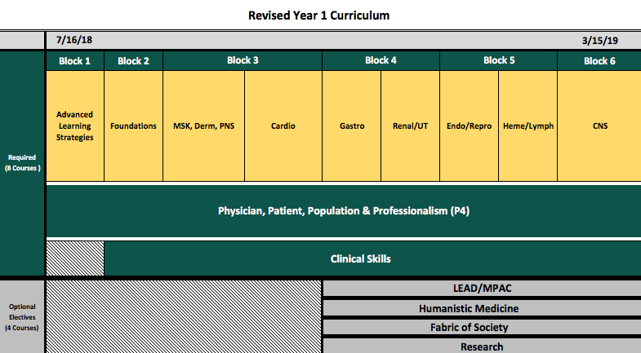

Future updates will be available via Connect the Docs and a soon-to-be-launched website.